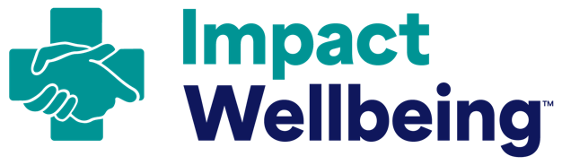
Sample Meeting Slide Content

How to use this meeting slide content:
- Adapt and use the following slide content to present your Professional Wellbeing Team’s progress updates to your workforce.
  - Include this information in your hospital’s existing materials or adapt this content as talking points for meetings.
- Plan to present this information during Grand Rounds, department meetings, nursing council meetings, or other opportunities when healthcare workers come together at
your hospital.
Sample Meeting Slide: Introducing Our Professional Wellbeing Team
Suggested Timing: One month after creating your Professional Wellbeing Team.
Slide Title: Introducing Our Professional Wellbeing Team
This new multidisciplinary group of representatives from across our organization will focus on reducing burnout and promoting the professional wellbeing of our workforce through operational changes over the next six months.
[Placeholders to include photos/headshots of the Professional Wellbeing Team leaders]

Sample Meeting Slide: We Changed Our Credentialing Application to Prioritize Wellbeing
Suggested Timing: One week after announcing your Professional Wellbeing Team.
Slide Title: We Changed Our Credentialing Application to Prioritize Wellbeing
The Professional Wellbeing Team has partnered with other leaders and staff to update our credentialing application. Our updated credentialing application questions are free from intrusive and stigmatizing language around mental health care and treatment.
- We have taken this step to ensure that our workforce can seek needed care without fear of professional retaliation.
- To ensure transparency, you can view questions from our credentialing application here at [LINK]
- Share this information with your colleagues, so they know that it is safe to seek mental health care and that we support you.

Sample Meeting Slide: Professional Wellbeing Plan Update
Suggested Timing: One week after drafting your Professional Wellbeing Plan (in Action 6).
Slide Title: Professional Wellbeing Plan Update

Our Professional Wellbeing Team is proud to share our plans for next steps to further create a safe and healthy environment for our healthcare workers.
In the next three months, we aim to:
- [INSERT LIST OF HIGH-LEVEL GOALS, REFERENCE PROFESSIONAL WELLBEING PLAN OUTLINE]
The Professional Wellbeing Team has begun to take these steps to better support you in delivering high quality patient care. We will share updates on our progress, including plans for next steps, in regular three-month intervals throughout the year.

